Family and Consumer Sciences Nutrition & Wellness / Food Preparation
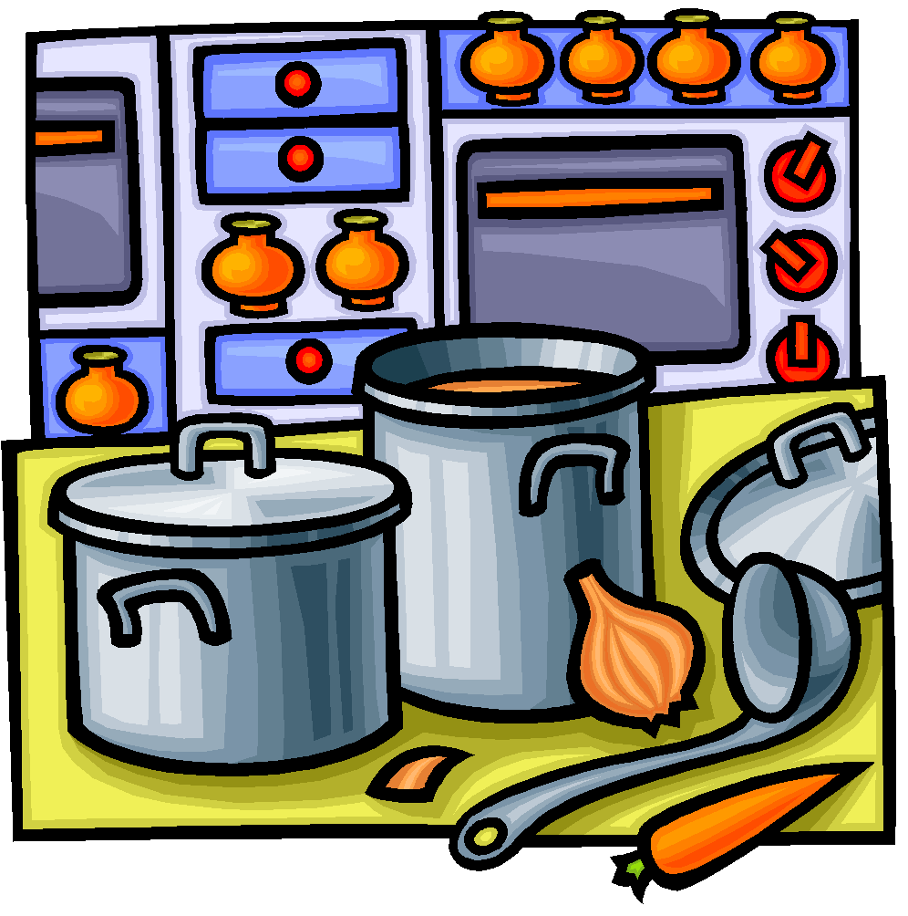
Mrs. Elizabeth Beattie

GRADE LEVEL: 9th - 12th
CREDITS: ½ Practical Arts Credit

COURSE DESCRIPTION
Nutrition and Wellness is the first of the Culinary Arts courses available at MCHS. In the spring semester, students transition into Food Preparation. Students will utilize the competencies of healthy eating and meal planning, kitchen and food safety, and sanitation. Students will focus on nutrition, use of kitchen equipment, cooking terms, basic food preparation techniques and careers in the food industry.

CULINARY ARTS CLASS SEQUENCE
RATIONALE

Nutrition and Wellness

Food Preparation

Food Science

Culinary Arts
The purpose of this course is to improve the health and quality of life of Missouri citizens by: constructing meaning related to nutrition, food economics and ecology; communicating effectively with family members, consumer groups and providers of food and nutrition products and services; solve problems related to health and wellness, as well as food needs through the application of mathematics and science principles; and make responsible decisions involving family and individual food needs, the use of the food dollar and the care of food.
NUTRITION & WELLNESS COURSE OBJECTIVES
Upon completion of this course students will be able to:
- Work as a team in a lab setting.
- Compare and contrast nutrient and calorie composition of foods
- Practice safety and sanitation following ServSafe guidelines
- Demonstrate basic culinary skills
- Compare ways to select, store, prepare, and serve food for optimum nutrition
FOOD PREPARATION COURSE OBJECTIVES
To improve the health and quality of life, this class will enable students to:
- select, store, and prepare all types of foods;
- analyze the nutritional content of food;
- calculate the cost per serving of food;
- demonstrate the principles and methods of cooking;
- apply math and science skills when preparing food;
- work as a team in a lab setting.
COURSE REQUIREMENTS
1. Complete all assigned work.
2. Turn in all projects and assignments by their due dates.
3. Students are expected to participate in small group assignments, provide examples in class discussion, and take notes when they are given in class.
4. KITCHEN LABS—Students are required to complete a kitchen lab contract before being allowed to work in the lab. If a student misses a lab, alternative assignments can almost always be made. Students are advised to give advance notice on absences when possible. Before school or during Seminar arrangements can be made to make up some assignments.
TEXT
Guide to Good Food, 2008, Goodheart-Willcox and ServSafe Essentials, National Restaurant Association Educational Foundation, are the textbooks for this class. A copy of Food for Today will not be given to students since they will get the information needed from notes in class.
SERVSAFE CERTIFICATION
Students will be taught the National Restaurant Association training for serving, storing, handling and preparing food products. After completing the ServSafe unit of instruction in the fall semester, students will be tested over the material in class. If the student would like to become “officially certified,” the student can take the National Restaurant Association’s ServSafe Certification test. This is available to students each fall semester, has to be proctored by Mrs. Beattie and costs $38.
ATTENDANCE/TARDY POLICY
Students are expected to be in the classroom on time and ready to work. Therefore, students arriving late without a pass are subject to the school district policy. Tardy count will start over at the beginning of each semester.
MAKE UP WORK
Assignments are due on the date designated. Students will be given 1 day to complete missed work for every EXCUSED absence. If you are present the day a test is announced, you are required to take the test even if you miss the day of review. For example, if you are gone on Wednesday, you will pick up your work Thursday before school and it will be due on Friday in class. ALL WORK IS DUE AT THE END OF THE UNIT. If we are preparing for a test, make sure everything is in.
Once you start your test, no late work will be taken for a grade.
1 day late = 80% credit 2 days late= 70% 3 days late= 60% 4 days late=50%
YOU ARE RESPONSIBLE FOR GETTING THE WORK YOU MISS AND MAKING UP YOUR WORK ON YOUR OWN TIME.
CHEATING
Cheating is never permitted. Students caught cheating will receive a zero on the exam or assignment and an office referral.

CELL PHONES
Students who have cell phones are expected to NOT HAVE THEM during class, from bell to bell. Phones are expected to be in their locker. If they are in a pocket, visible, or being used students will lose all points for the lab and lab privileges. NO PHONES ARE EVER ALLOWED IN THE KITCHEN. LOSS OF ALL POINTS WILL BE PENALTY.

CLASSROOM EXPECTATIONS
- Be ready for class to begin when the bell rings. This means in your seat and ready to work on the day’s activities. Have all of your required materials, supplies, and homework in class each day.
- You are expected to LEARN and WORK EVERY DAY throughout the ENTIRE CLASS PERIOD. (Sleeping or not paying attention will get you a warning and then an office referral.)
- Be responsible with your things and be respectful of others possessions and school supplies. Ask to borrow items from the teacher.
- You are required to sit in your assigned seat daily.
- The bell does not dismiss students, the teacher does. Please push in your chairs before leaving the classroom.
- Respect all opinions voiced by individuals in the classroom. Opinions are a way of sharing and thinking out problems and everyone is equally allowed to contribute.
- Masks will be worn in the kitchens when cooking.
TECHNOLOGY IMPLEMENTED IN COURSE
- Google Classroom— is a course website that will give students a place to store documents, access assignments from class in the form of worksheets, videos, etc, as well as give students a calendar with reminders of upcoming events/assignment deadlines.
INVITE LINK for 3rd HOUR: https://tinyurl.com/Beattie3
INVITE LINK for 5th HOUR: https://tinyurl.com/Beattie5
- Peardeck- www.peardeck.com/join is an online program we will use for note taking and class discussions.
- Quizlet / Quizizz—www.quizlet.com and www.quizizz.com are online studying programs that allow students to study virtual flashcards, turn the flashcards into multiple choice and true/false test questions as well as print the flashcards.
- INAPPROPRIATE TECHNOLOGY CONDUCT—Any access of inappropriate websites, pictures or files will result in loss of all technology rites in the entire building, not to mention the FACS department. Inappropriate posts or conduct on technology will cause the student to lose access to those resources at school as well as an office referral.

SUPPLIES NEEDED: Charged Chromebook pencil or pen

COURSE ASSIGNMENTS
Parents and students are encouraged to stay up to date on assignments that are due each day of class with the COURSE ASSIGNMENTS PAGE.

This is linked to the Google Classroom and updated each week for parents to use to ask questions of students on their progress in class and for students to use to access assignments.

To access the digital version that is updated weekly, go to GOOGLE CLASSROOM.

INTERNATIONAL FOODS & CULINARY ARTS TRAVEL RELEASE FORM

The undersigned, one of the parents or the legal guardian of ____________________________, a minor, hereby consents for said child to travel from Montgomery County R-2 High School to
Bratcher’s Market, Montgomery County Fairgrounds, Mrs. Garrett’s on Fall 2021 - Spring 2022 during class.
3rd Hour - Estimated departure time: 10:00 AM . Estimated return time: 10:56 AM .
4th Hour - Estimated departure time: 11:00 AM . Estimated return time: 12:21 PM .
5th Hour - Estimated departure time: 12:25 PM . Estimated return time: 1:21 PM .
I authorize (sponsor) Beth Beattie, and other adult sponsors of said trip to give their consent to and arrange for any and all emergency medical, surgical, and dental diagnosis, treatment and care which they deem necessary for said child while in their care; and I agree to pay for such services. I further authorize the sponsor and other adult sponsors of said trip to exercise control over said child and to administer reasonable disciplinary measures to said child to the extent they may deem necessary or expedient.

Dated this _________ day of ______________________, 20_____.

Any person violating these rules may be sent home at their own expense, may cause other participants or contestants from their school to be sent home or otherwise disqualify their members from participating in the activity.

Standards of Conduct
- I understand all rules and regulations as stated in the Montgomery Co. R-2 District Student Discipline Policies while on the trip.
- In accord with district policy, I will not possess or use alcohol, tobacco or any other drug while in attendance.
- I will, at all times, respect all public and private property, including the school bus.
- I will not leave the premises without the express permission of my advisor or chaperone. I will keep them informed of my whereabouts at all times and be back from a hike at my required time.
- I will be careful and cautious while working with the barbecue grill.

I understand that if, for any reason, I am in violation of any of the rules, I will be subject to appropriate consequences which could include being sent home at my own expense, the entire group being sent home, and/or office referral. Participation in such activities is a privilege that must be earned and maintained.
I have read and fully understand the Code of Conduct for participation in the activity and I agree to comply with these conduct guidelines. I am aware of the consequences that will result from violation of any of the above guidelines.

__________________________________________ ____________________________________
Student’s Signature Parent Signature

Relationship : Telephone Number

In case you are not available in the event of an emergency, whom shall we contact in your absence?

Name

Address Telephone Number

Name of Family Physician ________________________________________ Address__________________________________

Telephone Number __________________

Dear Parent,

Please read, sign, and return the bottom portion of the syllabus to me. Your signature indicates that you are aware of the classroom expectations and procedures for this class. By knowing what is expected, we can prevent potential problems during the school year.

Throughout the semester, we will be watching a variety of videos that demonstrate topics from eating healthy foods to food preparation. Your child will watch several clips from: Portion Distortion, Super Size Me and Honey Boo Boo clip. There will also be a variety of Food Network and Cooking Channel shows as well as demonstrations from YouTube. Examples include: Dinner Impossible, Chopped, Cupcake Wars, Throw Down with Bobby Flay.

Please SIGN UP FOR A PARENT GOOGLE CLASSROOM account. This is the communication tool that I will use for many things throughout class. It posts links the students will need, a calendar of deadlines and events, some projects/assignments are turned in using this website, and it allows students to save work between home and school computers without a flash drive.
To sign up:
3rd Hour: https://tinyurl.com/Beattie3
5th Hour: https://tinyurl.com/Beattie5
I encourage communication concerning student progress and conduct to ensure a positive experience throughout the course. Please feel free to call the office or e-mail me to set up an appointment for a parent conference at any point throughout the semester.

I am always glad parents acknowledge the importance of youth and their education. Active participation is the key to success. I look forward to building a relationship with your child and family.

Sincerely,

Mrs. Beth Beattie
CONTACT: bbeattie@mc-wildcats.org

Syllabus for: NUTRITION & WELLNESS / FOOD PREPARATION
Students,
This is your first assignment and is worth 10 points. Please read and discuss the syllabus with your parents/guardians.

Student: ___________________________________________
(Signature)

Please select which describes your learning situation if we were to go virtual this school year.
O I have the internet and can complete school work using it. O I would like to have my assignments printed and sent to me.

Parents,
Please READ through the syllabus and this sheet with your child. All missing work information, videos, and extra information that you should know about your child’s class is there.

________________________________________________________
(Parent/Guardian Signature)

Throughout the year, students will create projects or community service events in class and with student organizations like FCCLA. Students will be able to take pictures or video footage of their finished projects or during demonstrations of course learning. These pictures or videos will be used in student portfolios, the local newspaper, or the school website.

