Family and Consumer Sciences Child Development 1 / Child Development 2
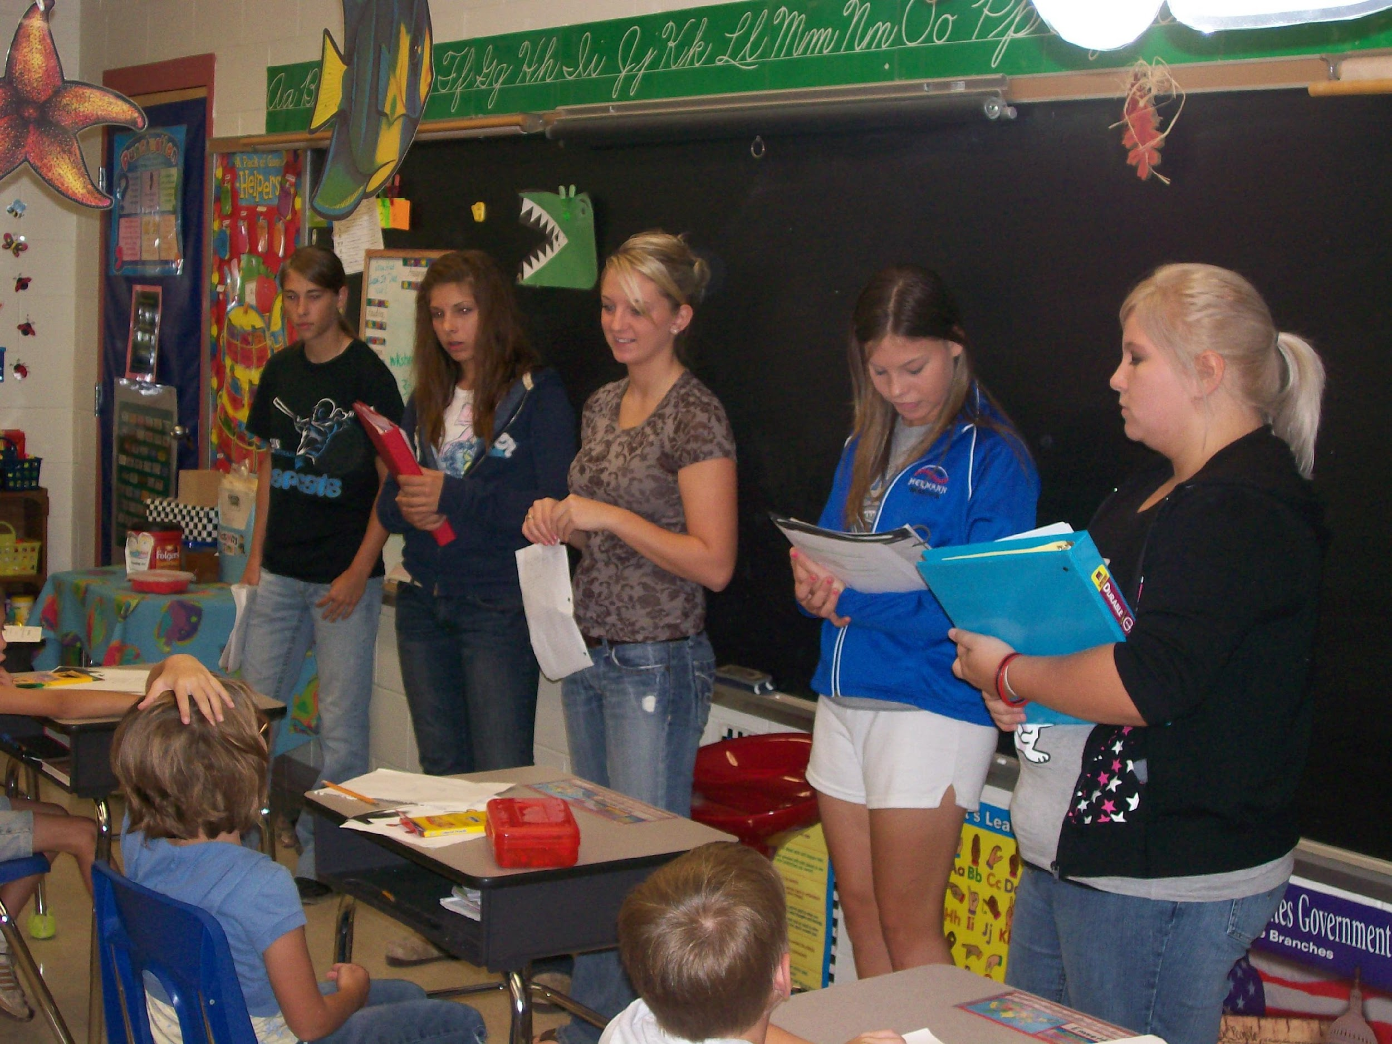
Mrs. Elizabeth Beattie

GRADE LEVEL: 9th - 12th
CREDITS: ½ Practical Arts Credit per course

COURSE DESCRIPTION
Child Development is a course that prepares students for the intellectual, social, emotional, and biological development of children. This class focuses on the importance of parent-child relations, parenting practices, special needs of children, and parental and environmental influences on child development.

RATIONALE
The purpose of this course is to provide students with the skills for success for dealing with family, career and community life. This course will enable students to interpret the function and significance of pertinent child care, guidance and supervision, communicate effectively with family members, child care agencies and professional service providers, solve problems based upon the developmental needs of children, and make decisions that support the sound physical, mental and social development of children. Through this class we will focus on the impact the parenting role has on individuals, families, and communities.

CHILD DEVELOPMENT 1 OBJECTIVES
A+ Tutoring Hours:

Child Development 2 = 15+ Hours

Special Olympics =
6+ Hours

Upon completion of this course students will be able to:
- Evaluate factors and choices related to parenting across lifespan
- Develop changes and adaptations needed for parenting roles across lifespan
- Explain effects of substance use and abuse related to pregnancy
- Basic principles of human development from prenatal development to death
- Developmental tasks and interrelations of family members through the lifespan
- Devise strategies for coordinating work and family responsibilities
- Identify characteristics of effective parenting
- Compare and contrast guidance and discipline
- Describe signs of abuse and neglect and available community resources for these issues

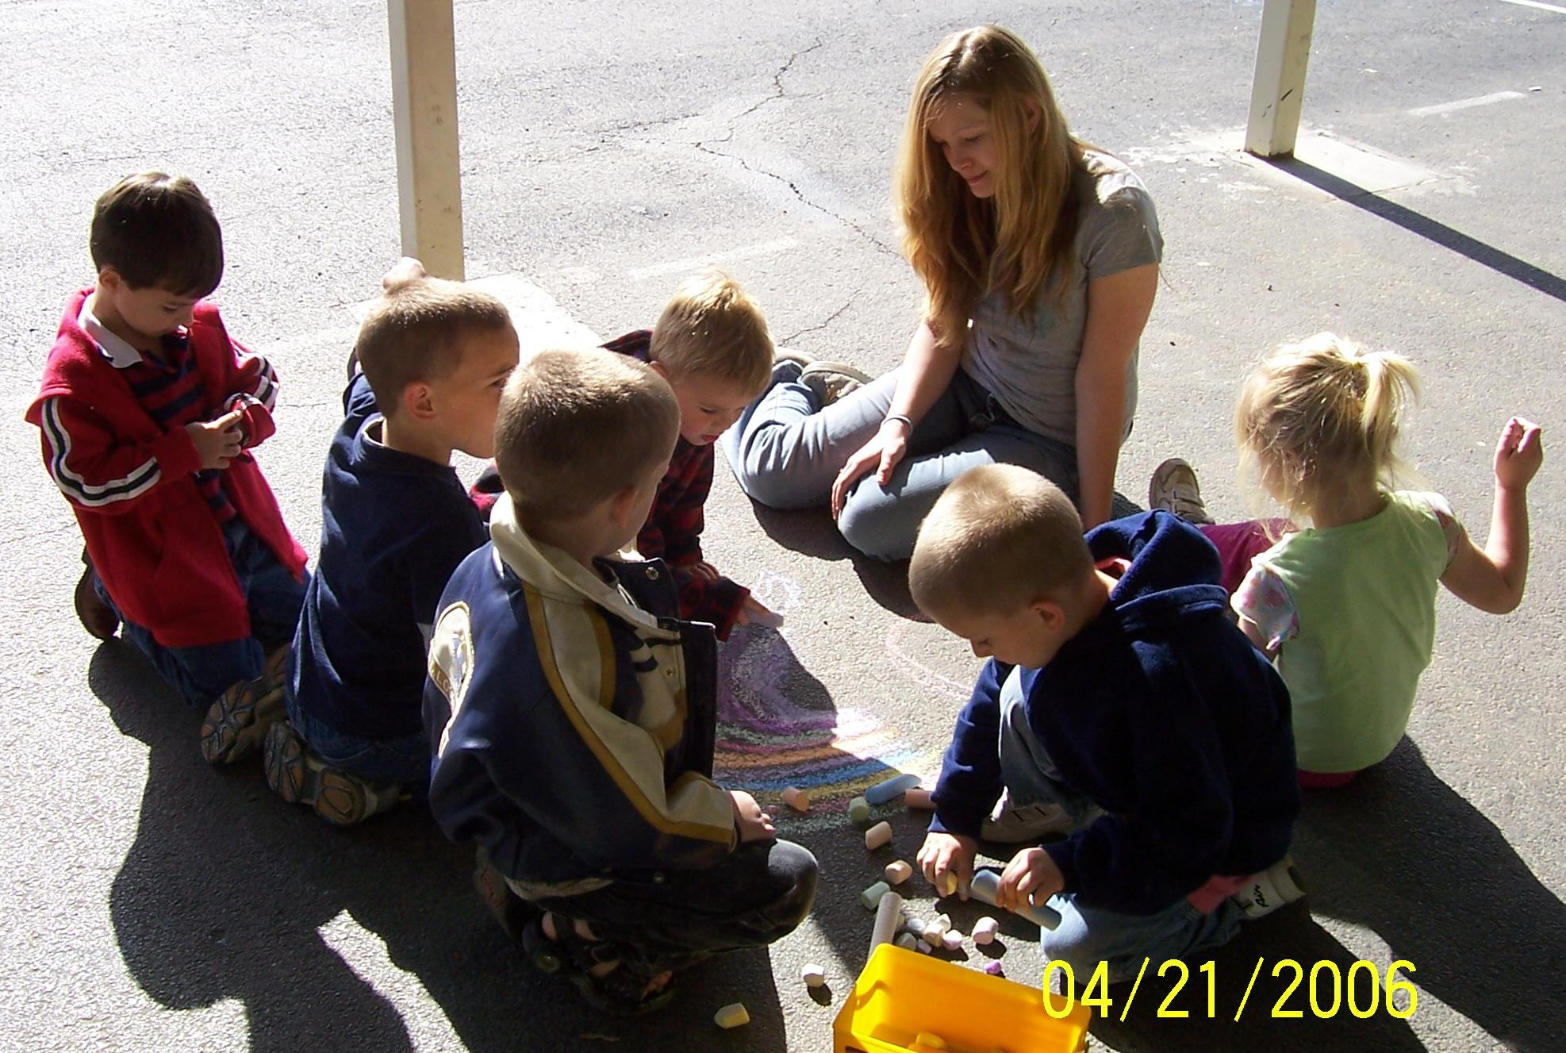
CHILD DEVELOPMENT 2 OBJECTIVES
Upon completion of this course students will be able to:
- Evaluate factors and choices related to parenting from conception through adolescence
- Develop changes and adaptations needed for parenting roles
- Explain the ethical responsibilities of working with children
- Explore different theories of child development
- Devise strategies for coordinating work and family responsibilities
- Provide a positive role model for young children
- Compare and contrast normal and atypical child development
- Identify, plan, and lead age-appropriate activities for children
COURSE REQUIREMENTS
1. Complete all assigned work.
2. Turn in all projects and assignments by their due dates. Students will only be able to obtain partial credit on work turned in after the deadline.
3. Students are expected to participate in small group assignments, provide examples in class discussion, and take notes when they are given in class.
4. Serve as a positive influence for the elementary students you are working with in Child Development 2. If unable to be a POSITIVE ROLE MODEL, you will have to stay at the high school, unable to receive credit for each elementary school visit.
5. Students are required to attend all elementary visits. You will be given ONE excused miss for a school sponsored trip or regularly excused absence. After your one miss, any additional misses will result in the loss of points for that day.

TEXT
The Developing Child is the textbook for this class, and will be one of the many resources that we utilize for instruction. No textbooks will be assigned to student since most information from the text will be received in notes. There will also be supplemental materials used and most of these will not be available to leave the classroom unless they are signed out by the student.

ARTICULATION AGREEMENT
If you are planning on attending St. Charles Community College, Child Development 1 and 2 can be taken as an articulated credit. Both classes transfer to SCC as CDC 112-Child Growth & Development 1. To receive credit, SCC requires you to have a “B” or better in the high school classes and to take CDC 113-Child Growth & Development 2 and have a “C” or better. Students must sign up by September.

DUAL CREDIT
Child Development 1 is available as a dual credit course through Missouri State University. To be eligible, students must have a GPA of 3.0 and either an 18+ on the Plan or a 21+ on the ACT. Child Development 1 students will receive 3 hours of credit for CFD 155: Principles of Human Development. THIS COURSE IS A GENERAL EDUCATION REQUIREMENT FOR ALL MAJORS AT MISSOURI STATE.
CFD 160: Principles of Development—Early Childhood is the 3 credit hour course for Child Development 2. These courses can transfer as electives, or serve as classes needed by many Psychology or Education related majors. This course does have a fee, but as a dual credit it is only ½ price compared to being a MSU campus student, FREE for free and reduced lunch status families if you have a 3.0 GPA, and FREE after school district reimbursement for any student in a Career and Technical Education classroom, like Family and Consumer Sciences till 2023! That means, all students can register, pay the reduced rate now and be reimbursed by MCR2 if the student passes the course. Students must sign up before September and meet MSU requirements to enroll.
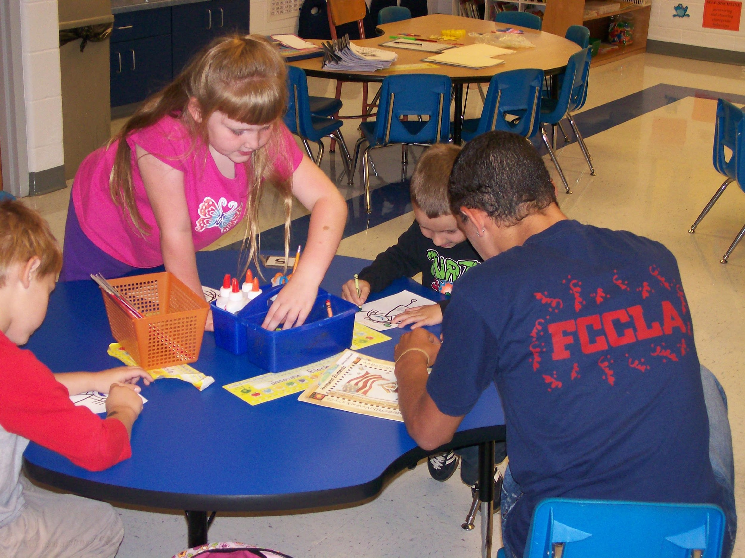
ELEMENTARY SCHOOL
Child Development 1 students will be working together in groups to create a workshop for elementary students. Selecting a community concern for the age-group, students will use their child development knowledge to create activities to education the elementary students.

Child Development 2 students will be working with one classroom each Friday at the elementary school. Students will spend 45 minutes working one-on-one with students on math, reading, grammar/spelling, or reading comprehension skills.

REAL CARE BABY SIMULATORS—CHILD DEVELOPMENT 1 PROJECT
Throughout the second half of fall semester, students will begin signing up for the baby simulators. Students are required to parent the child for 48 hours. Along with providing care, students will have to document their time, feelings and level of stress. This project is not the same as having a real child, but it is the closest technology can create. If you and your child decide not to participate in the baby simulation project, an alternative project is available. It requires documented babysitting hours and research on becoming a parent. Either way, information will be coming home for parents and students to discuss and return in the next month.

EMPATHY BELLY SIMULATOR—CHILD DEVELOPMENT 1 PROJECT
Another fall semester project is the Empathy belly. The weighted suit allows students to feel the effects of the changing body through pregnancy. As weights are added, the suit weights about 30 pounds. Students wear the suit for one class period and must complete various activities with a partner. Activities include getting up from a sitting position, tying a shoe, etc. An alternative assignment is available.

ATTENDANCE/TARDY POLICY
Students are expected to be in the classroom on time and ready to work. Therefore, students arriving late without a pass are subject to the school district policy. Tardy count will start over at the beginning of each semester.

MAKE UP WORK
Assignments are due on the date designated. Students will be given 1 day to complete missed work for every EXCUSED absence. If you are present the day a test is announced, you are required to take the test even if you miss the day of review. For example, if you are gone on Wednesday, you will pick up your work Thursday before school and it will be due on Friday in class.
ALL WORK IS DUE AT THE END OF THE UNIT. If we are preparing for a test, make sure everything is in.
Once you start your test, no late work will be taken for a grade.
1 day late = 80% credit 2 days late= 70% 3 days late= 60% 4 days late=50%
YOU ARE RESPONSIBLE FOR GETTING THE WORK YOU MISS AND MAKING UP YOUR WORK ON YOUR OWN TIME.
CHEATING
Cheating is never permitted. Students caught cheating will receive a zero on the exam or assignment and an office referral.
CELL PHONES
Students who have cell phones are expected to NOT HAVE THEM FROM BELL TO BELL. Phones stay in their locker. Phones are NOT ALLOWED to go to the elementary school, this results in an automatic referral.
CLASSROOM EXPECTATIONS
- Be ready for class to begin when the bell rings. This means being in your seat and ready to work on the day’s activities. Have all of your required materials, supplies, and homework in class each day.
- You are expected to LEARN and WORK EVERY DAY throughout the ENTIRE CLASS PERIOD. (Sleeping or not paying attention will get you a warning and then an office referral.)
- Be responsible with your things and be respectful of others possessions and school supplies. Ask to borrow items from the teacher.
- You are required to sit in your assigned seat daily.
- The bell does not dismiss students, the teacher does. Please push in your chairs before leaving the classroom.
- Respect all opinions voiced by individuals in the classroom. Opinions are a way of sharing and thinking out problems and everyone is equally allowed to contribute.
TECHNOLOGY IMPLEMENTED IN COURSE
- Google Classroom— is a course website that will give students a place to store documents, access assignments from class in the form of worksheets, videos, etc, as well as give students a calendar with reminders of upcoming events/assignment deadlines. INVITE LINK: https://classroom.google.com/c/MzcyNzkzODgyMTM3?cjc=5moaxdg
- Quizizz & Quizlet—www.quizlet.com is an online program that allows students to study virtual flashcards, turn the flashcards into multiple choice and true/false test questions as well as print the flashcards.
- Peardeck- www.peardeck.com/join is an online program we will use for note taking and class discussions.
- INNAPPROPRIATE TECHNOLOGY CONDUCT—Any access of inappropriate websites, pictures or files will result in loss of all technology rites in the entire building, not to mention the FACS department. Inappropriate posts or conduct on technology will cause the student to lose access to those resources at school as well as an office referral.
BATHROOM/LOCKER PASS—Students will have the opportunity to go to the bathroom after group notes, discussion or work is completed in the first half of class.
SUPPLIES NEEDED: Charged Chromebook pencil or pen
COURSE ASSIGNMENTS

Parents and students are encouraged to
stay up to date on assignments that are due each day of class with the COURSE ASSIGNMENTS PAGE.

This is linked to the Google Classroom and updated each week for parents to use to ask questions of students on their progress in class and for students to use to access assignments.
To access the digital version that is updated weekly, go t Google Classroom.

Dear Parent,

Please read, sign, and return this page to me. Your signature indicates that you are aware of the classroom expectations and procedures for this class. By knowing what is expected, we can prevent potential problems during the school year.

Throughout the semester, we will be watching a variety of videos that demonstrate topics from developmental stages to parenting styles. Your child will watch several clips from: Super Nanny, TLC’s Jon and Kate Plus 8 (Two parents with a set of elementary school age twins, plus 6 toddlers) or the newer version, Kate Plus 8, and A Baby Story.

Students will also see video clips on specific topics: You Matter, Truth and Consequences, and Healthy Lifestyle (All three produced by the March of Dimes); Childcare with Maria Shriver, Teen Pregnancy (produced by the National Foundation for Teen Pregnancy Prevention), And Down will Come Baby (substance abuse), Child Safety, Elijah’s Story (Shaken Baby Syndrome), and Infant CPR and First Aid, How I Learn, and Ages and Stages of Development.

We will also be watching a video on child birth that is fairly graphic produced by National Geographic entitled, In the Womb. Our prenatal development unit begins in October. If you have any questions or concerns with this please feel free to contact me at any time as we go through the semester.

Please SIGN UP FOR A PARENT GOOGLE CLASSROOM account. This is the communication tool that I will use for many things throughout class. It posts links the students will need, a calendar of deadlines and events, some projects/assignments are turned in using this website, and it allows students to save work between home and school computers without a flash drive.
To sign up: Go to https://classroom.google.com/c/MzcyNzkzODgyMTM3?cjc=5moaxdg

I encourage communication concerning student progress and conduct to ensure a positive experience throughout the course. Please feel free to call the office or e-mail me to set up an appointment for a parent conference at any point throughout the semester.

I am always glad parents acknowledge the importance of youth and their education. Active participation is the key to success. I look forward to building a relationship with your child and family.

Sincerely,

Mrs. Beth Beattie

CONTACT: bbeattie@mc-wildcats.org

Syllabus for: CHILD DEVELOPMENT 1 / CHILD DEVELOPMENT 2
Students,
This is your first assignment and is worth 10 points. Please read and discuss the syllabus with your parents/guardians.

Student: ___________________________________________
(signature)
Please select which describes your learning situation if we were to go virtual this school year.
O I have the internet and can complete school work using it. O I would like to have my assignments printed and sent to me.

Parents,
Please READ through the two-page syllabus and this sheet with your child. All missing work information, videos, and extra information that you should know about your child’s class is there. Your signature is also allowing your student to participate in video zoom sessions with MCE or JBE students to read books and other related curriculum activities as this year we will be unable to actually visit these classrooms of students.

i
________________________________________________________
(Parent/Guardian Signature)
Throughout the year, students will create projects or community service events in class and with student organizations like FCCLA. Students will be able to take pictures or video footage of their finished projects or during demonstrations of course learning. These pictures or videos will be used in student portfolios, the local newspaper, or the school website.
CHILD DEVELOPMENT 1 & 2 TRAVEL RELEASE FORM

The undersigned, one of the parents or the legal guardian of ____________________________, a minor, hereby consents for said child to travel from Montgomery County R-2 High School to Montgomery County R-2 Elementary School, Jonesburg Elementary School, Montgomery City Head Start Child Development Center, the local library on scheduled dates throughout the semester.
Estimated departure time: 8:00 AM . Estimated return time: 8:56 AM .
(All trips will take place during your child’s class period.)

I authorize (sponsor) Beth Beattie, and other adult sponsors of said trip to give their consent to and arrange for any and all emergency medical, surgical, and dental diagnosis, treatment and care which they deem necessary for said child while in their care; and I agree to pay for such services. I further authorize the sponsor and other adult sponsors of said trip to exercise control over said child and to administer reasonable disciplinary measures to said child to the extent they may deem necessary or expedient.

Dated this _________ day of ______________________, 20_____.

Confidentiality:
I understand that the conversations between any students, teachers, or workers are not for public knowledge. Abiding by the school district’s confidentiality code means that I will not share with others my experiences at the child development centers, in an effort to protect the students’ privacy.

__________________________________________ ____________________________________
Student’s Signature Parent Signature

Relationship Telephone Number

In case you are not available in the event of an emergency, whom shall we contact in your absence?

Name

Address

Telephone Number

Name of Family Physician ____________________________________________

Address___________________________________________________ Telephone Number __________________

