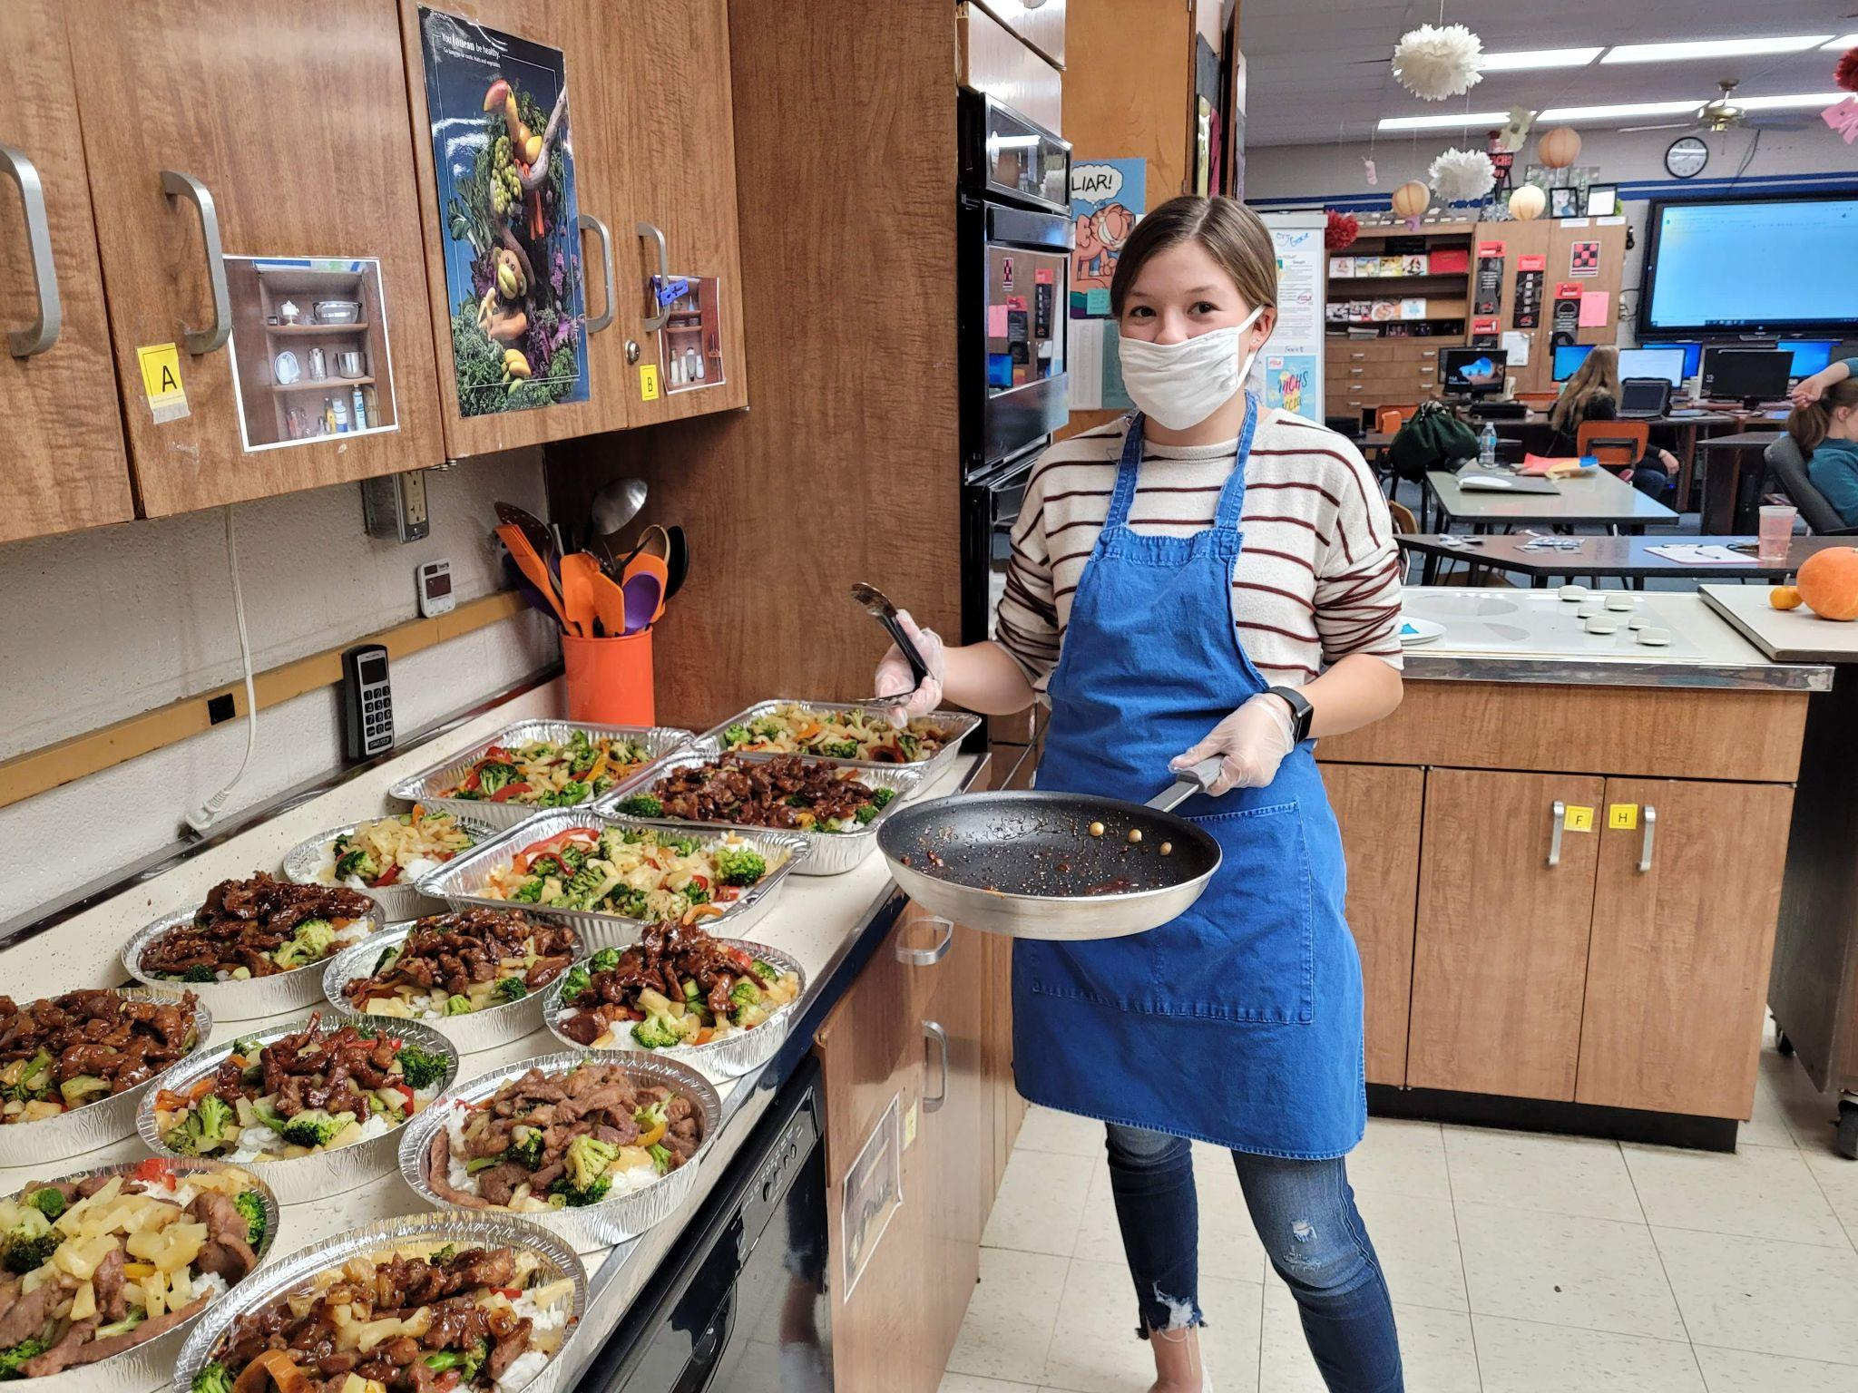
Family and Consumer Sciences Entrepreneurship
Mrs. Elizabeth Beattie
GRADE LEVEL: 9th – 12th
CREDITS: 1 Practical Arts Credit (year-long)

COURSE DESCRIPTION
Career Development and Entrepreneurship is a course that provides students with the opportunity to learn more about FCCLA, develop their leadership potential, and assist the community with chapter service projects.

RATIONALE
The purpose of the Career and Family Leadership course is to assist students in preparing for success in family, career and community life; promote personal growth and leadership development; explore work, jobs, and careers related to family and consumer sciences; learn about entrepreneurship ventures and assess personal entrepreneurial traits.
COURSE OBJECTIVES
Upon completion of this course students will be able to:
- Utilize FCCLA programs to promote personal growth and leadership development
- Develop a plan for achieving career goals
- Assuming Leadership Roles as Responsible Family Members and Citizens
- Exploring Entrepreneurship
- Assessing Entrepreneurship Traits

COURSE REQUIREMENTS
1. Be excited and eager to learn about FCCLA and to take part in FCCLA activities. Students are strongly encouraged to become an FCCLA member and participate in STAR Events and Community Service activities.
2. Students are expected to act like young leaders. Actions should be respectable and students should exhibit character traits to others.
3. Turn in all projects and assignments by their due dates.
4. Students are expected to participate in small group assignments, as we are RUNNING A MONTHLY BUSINESS. They are responsible for contributing to their committee each class period.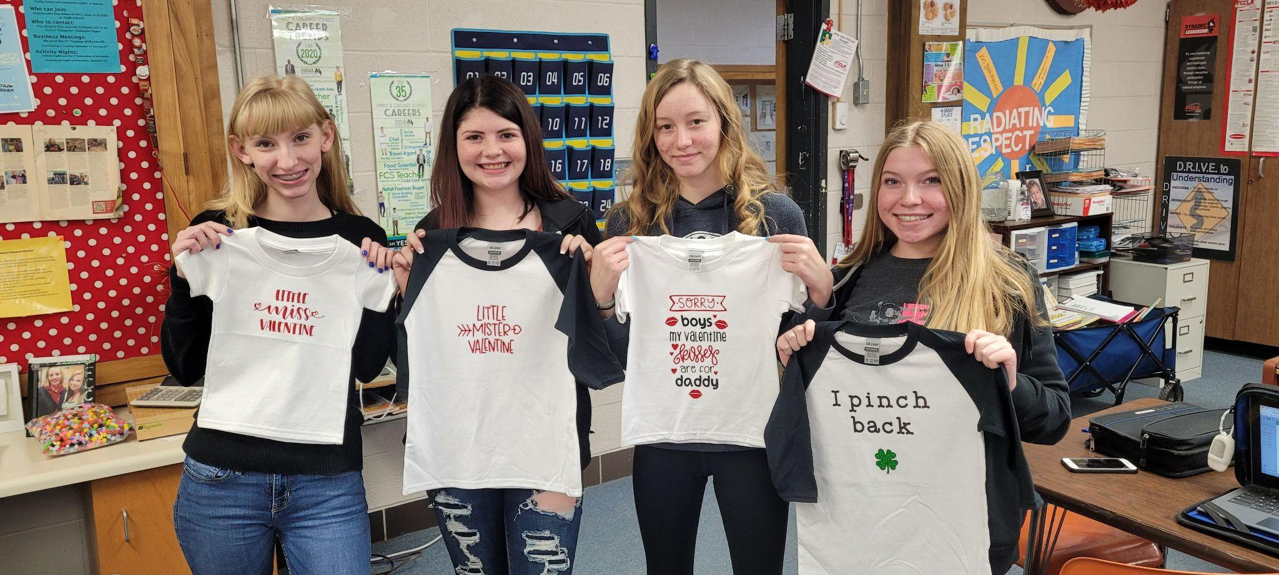

TEXT
There will be no required textbook for this class. However, students will be required to complete project reports and other assignments using computers in the classroom.
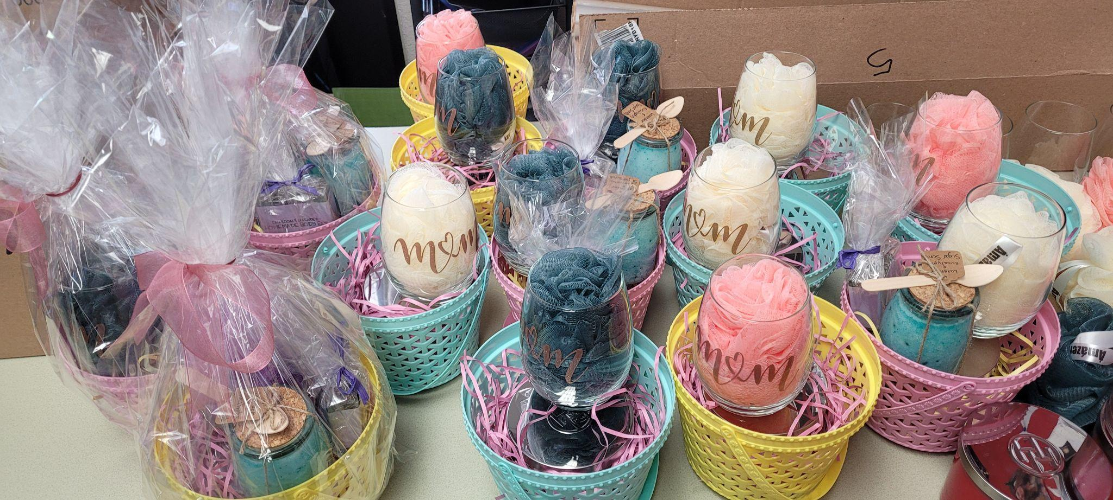
ATTENDANCE/TARDY POLICY
Students are expected to be in the classroom on time and ready to work. Therefore, students arriving late without a pass are subject to the following policy. Tardy count will start over at the beginning of each semester.
MAKE UP WORK
At the beginning of the year, students are working on career development skills and projects that can be completed on their own if absent. As the school year progresses, this class becomes a business. Students will be working on creating items that will be sold to the public. Working with students, we came to an agreement of 8 “sick days” or absences per semester are given without grade penalty. Some days, students will still be required to complete work outside of class, however, some projects are only able to be completed in school due to equipment needed and can not be made up. Any absences after 8, students will need to ask for alternative projects that are graded in place of their work in class.

CHEATING / INAPPROPRIATE CONDUCT
Cheating is never permitted. Students caught cheating will receive a zero on the exam or assignment and an office referral. As we are working with food and products for families in our community, basic national restaurant association food safety is required. If students are breaking food code rules, they will be warned and/or required to leave the lab resulting in a loss of points for the day.

CELL PHONES
Students should not have phones on them in class. They can be stored in their chromebook case, but not on them. Students are not allowed to be on their phones and will have to turn them into the office if out in class. .
CLASSROOM EXPECTATIONS
- Be ready for class to begin when the bell rings. This means in your seat and ready to work on the day’s activities. Have all of your required materials, supplies, and homework in class each day.
- FCCLA supplies are expensive, and we aren’t rich. Be conservative and ASK BEFORE TAKING things.
- Respect all opinions voiced by individuals in the classroom. Opinions are a way of sharing and thinking out problems and everyone is equally allowed to contribute. If you are going to get yourself in trouble, not following this rule will do it.
- The bell does not dismiss students, the teacher does. Please make sure your desk is pushed back into its place before leaving the classroom.
- Be responsible. You are a young leader with lots of opportunities ahead of you, so act accordingly. Have the things you need for your project with you, remember deadlines, and be responsible for your actions.
- You are expected to LEARN and WORK EVERY DAY throughout the ENTIRE CLASS PERIOD. (Sleeping or not paying attention will get you a warning and then an office referral.)
Students will receive a daily grade. This will be evaluated by either self-assessment, teacher evaluation, or a project rubric. If you are absent, and you were unable to do things necessary for community service project’s design, development, or execution. Missing certain assignments, such as a large group project development day or STAR event prep day, will result in the loss of a large amount of points with no alternative assignment. Students will get opportunities to make some project planning outside of class. Students will have to make an effort to meet with their group partner(s) and/or Mrs. Beattie to earn credit in most cases. All efforts to assist the student in other school-sponsored trips or activities will be granted.

TECHNOLOGY IMPLEMENTED IN COURSE
- Google Classroom— is a course website that will give students a place to store documents, access assignments from class in the form of worksheets, videos, etc, as well as give students a calendar with reminders of upcoming events/assignment deadlines. Parents, you are able to shadow the class and see everything that is posted.
INVITE CODE FOR PARENTS: https://tinyurl.com/Beattie6
- INAPPROPRIATE TECHNOLOGY CONDUCT—Any access of inappropriate websites, pictures or files will result in loss of all technology rites in the entire building, not to mention the FCS department. Inappropriate posts or conduct on Edmodo will cause the student to lose access to those resources at school as well as an office referral.

- SUPPLIES NEEDED—Charged Chromebook, pencils/pens (Additional materials for business as needed.)

Dear Parent,

Please read, sign, and return the bottom portion of the syllabus to me. Your signature indicates that you are aware of the classroom expectations and procedures for this class. By knowing what is expected, we can prevent potential problems during the school year.

The students will have the opportunity to be actively involved in the community in this class. I hope to see your son or daughter in the paper quite often for their various community service projects or leadership roles. There may also be times that your student will need to be taken to the elementary school, library, Head Start, or other community locations associated with community service projects he or she chooses. Your child will bring home a travel release which addresses these concerns if that situation arises.

Please SIGN UP FOR A PARENT GOOGLE CLASSROOM ACCOUNT. This is the communication tool that I will use for many things throughout class. It posts links the students will need, a calendar of deadlines and events, some projects/assignments are turned in using this website, and it allows students to save work between home and school computers without a flash drive. INVITE CODE: https://tinyurl.com/Beattie6

Throughout the semester, we will be watching a variety of video clips that demonstrate a variety of community service areas. Examples include dating violence, bullying, leadership training, communication training, job interviewing, substance abuse, and poverty. If you have any questions on these topics, please do not hesitate to give me a call.
I encourage communication concerning student progress and conduct to ensure a positive experience throughout the course. Please feel free to call the office or e-mail me to set up an appointment for a parent conference at any point throughout the semester.

I am always glad parents acknowledge the importance of youth and their education. Active participation is the key to success. I look forward to building a relationship with your child and family.

Sincerely,

Mrs. Beth Beattie

Elizabeth Beattie
CONTACT: bbeattie@mc-wildcats.org

Syllabus for: CAREER DEVELOPMENT / ENTREPRENEURSHIP
Students,
This is your first assignment and is worth 10 points. Please read and discuss the syllabus with your parents/guardians.

Student’s name: ___________________________________________
(Student’s Signature)

Please select which describes your learning situation if we were to go virtual this school year.
O I have the internet and can complete school work using it. O I would like to have my assignments printed and sent to me.

Parents,
Please READ through the two-page syllabus and this sheet with your child. All missing work information, videos, and extra information that you should know about your child’s class is there.

________________________________________________________
(Parent/Guardian Signature)
Throughout the year, students will create projects or community service events in class and with student organizations like FCCLA. Students will be able to take pictures or video footage of their finished projects or during demonstrations of course learning. These pictures or videos will be used in student portfolios, the local newspaper, or the school website.

